Triangle Incenter

Definition
# Source: AI Source: Provided by: [Data Path: Persons Table -> ID Column: 1, Name_En Column: Motasem Essam] -> From: [ChatGPT] on [7/25/2026]
The Triangle Incenter is the point where the three internal angle bisectors of a triangle intersect.
The incenter is commonly denoted by:
$$\boxed{I}$$
For triangle $△ABC$, if the internal angle bisectors of $∠A$, $∠B$, and $∠C$intersect at $I$, then $I$is the incenter of the triangle.
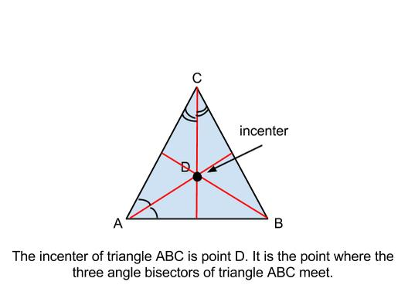
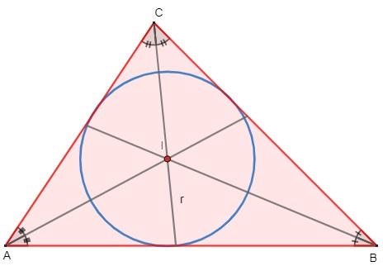
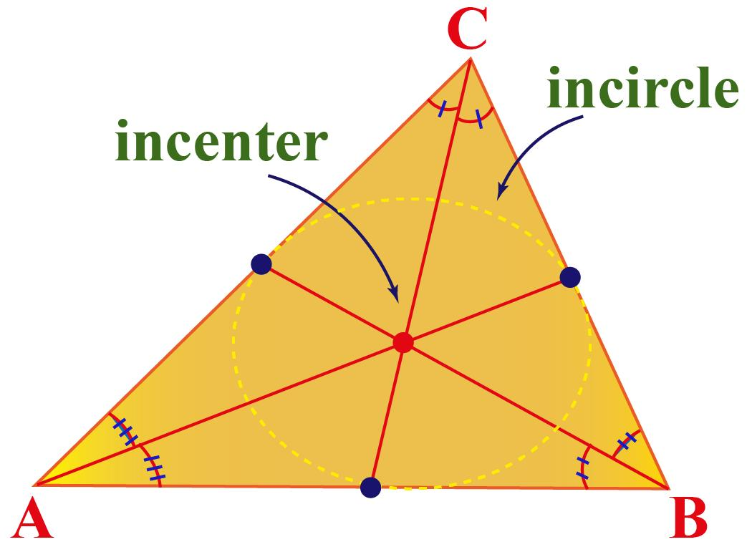
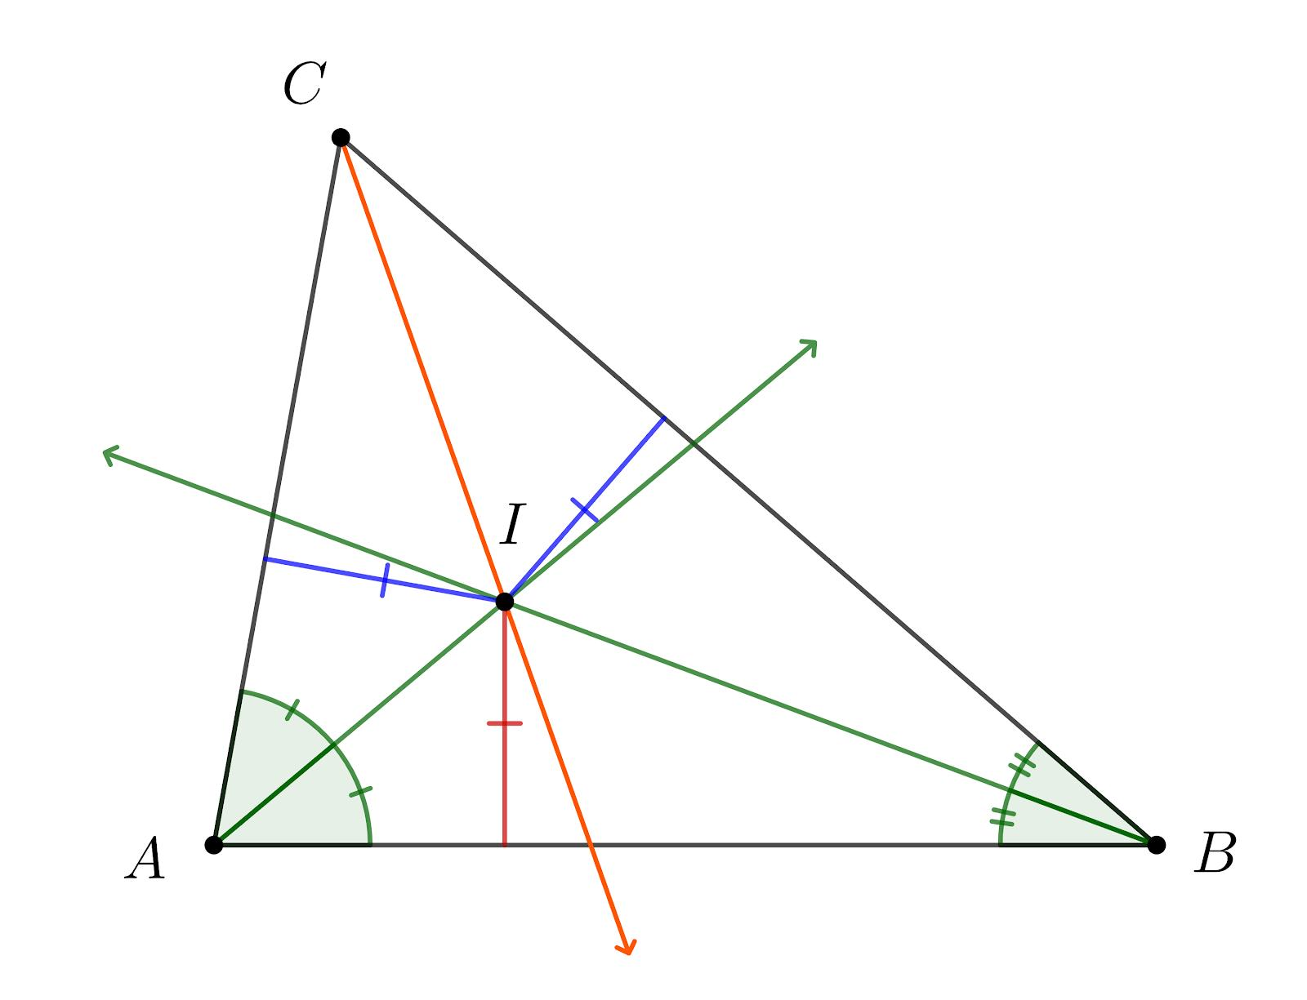
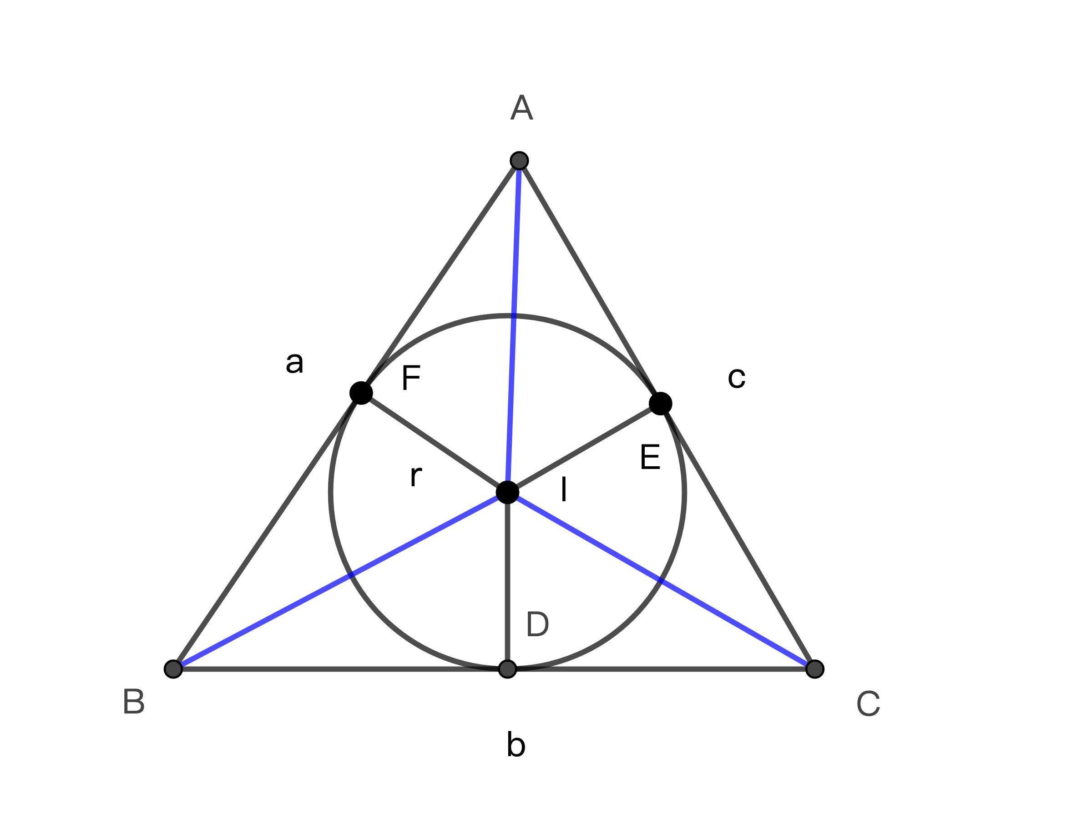

Purpose
# Source: AI Source: Provided by: [Data Path: Persons Table -> ID Column: 1, Name_En Column: Motasem Essam] -> From: [ChatGPT] on [7/25/2026]
The incenter is used to:
- Locate the center of the incircle.
- Determine the point that is equidistant from all three sides of a triangle.
- Find the radius of the incircle.
- Calculate triangle area using the inradius.
- Solve problems involving angle bisectors.
- Study relationships among triangle centers.

Fundamental Elements
# Source: AI Source: Provided by: [Data Path: Persons Table -> ID Column: 1, Name_En Column: Motasem Essam] -> From: [ChatGPT] on [7/25/2026]
For $△ABC$:
Element | Description
$$A,B,C$$ | Vertices of the triangle
$$I$$ | Incenter
Internal angle bisectors | Lines that divide the three angles into two equal angles
$$r$$ | Inradius
Incircle | Circle centered at $I$tangent to all three sides
The defining relationship is:
$$\boxed{I=\text{intersection of the three internal angle bisectors}}$$

Angle Bisectors
# Source: AI Source: Provided by: [Data Path: Persons Table -> ID Column: 1, Name_En Column: Motasem Essam] -> From: [ChatGPT] on [7/25/2026]
An angle bisector divides an angle into two equal angles.
For example, if $AI$bisects $∠A$, then:
$$\boxed{∠BAI=∠IAC}$$
Similarly:
$$∠ABI=∠IBC$$
and:
$$∠ACI=∠ICB$$
Therefore, $I$lies on all three internal angle bisectors.

Incenter Theorem
# Source: AI Source: Provided by: [Data Path: Persons Table -> ID Column: 1, Name_En Column: Motasem Essam] -> From: [ChatGPT] on [7/25/2026]
The Incenter Theorem states:
The three internal angle bisectors of a triangle are concurrent at a single point called the incenter.
Thus:
$$\boxed{AI∩BI∩CI=\left\{I\right\}}$$
The incenter is always located inside a nondegenerate triangle.

Equidistance from the Three Sides
# Source: AI Source: Provided by: [Data Path: Persons Table -> ID Column: 1, Name_En Column: Motasem Essam] -> From: [ChatGPT] on [7/25/2026]
One of the most important properties of the incenter is that it is equally distant from all three sides.
If perpendiculars from $I$meet:
- $AB$at $D$
- $BC$at $E$
- $CA$at $F$
then:
$$\boxed{ID=IE=IF}$$
This common distance is called the inradius:
$$\boxed{r=ID=IE=IF}$$
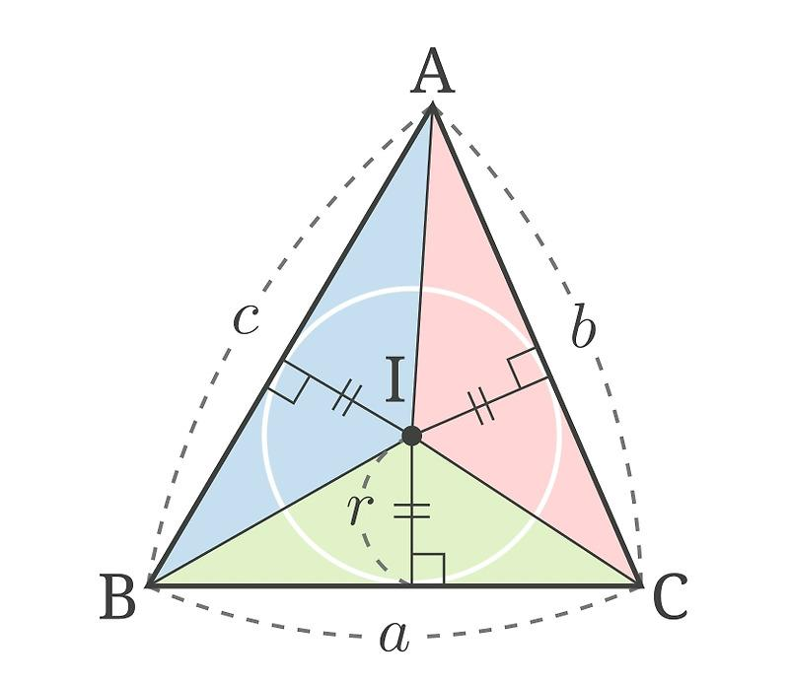
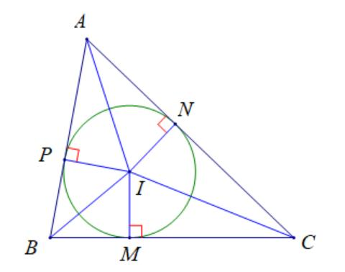
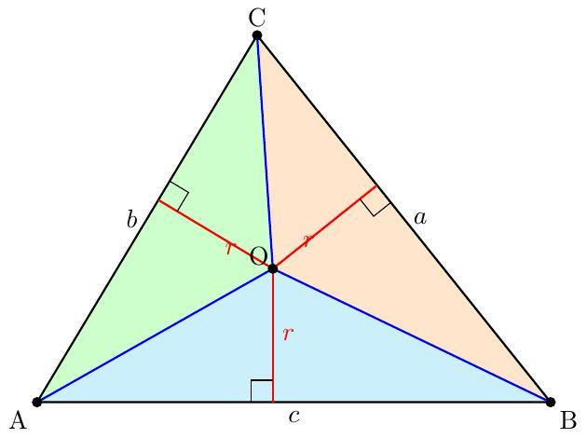
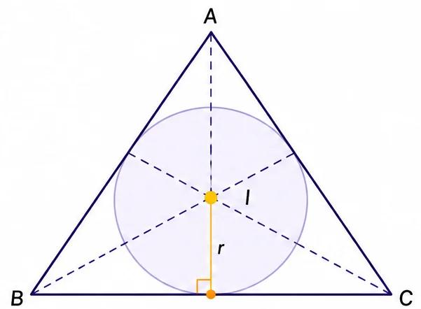
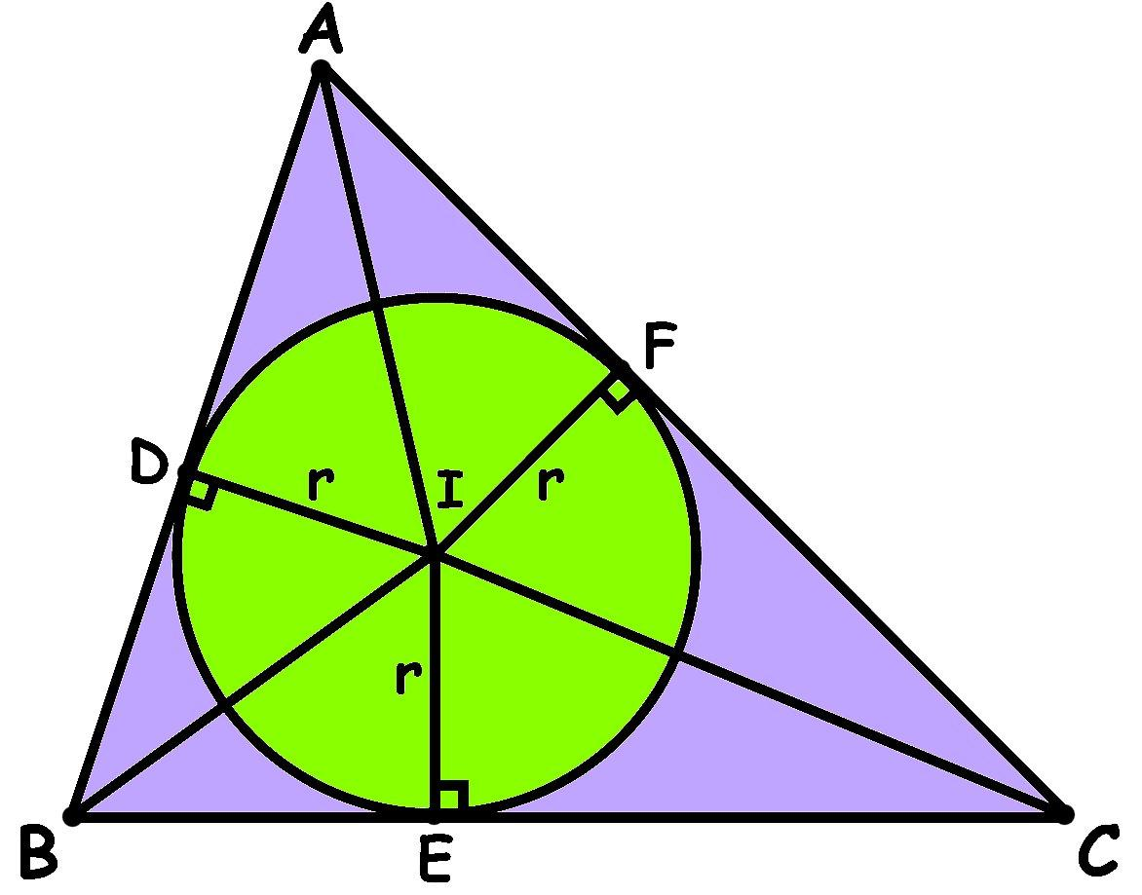

Incircle
# Source: AI Source: Provided by: [Data Path: Persons Table -> ID Column: 1, Name_En Column: Motasem Essam] -> From: [ChatGPT] on [7/25/2026]
The incircle is the circle centered at the incenter that is tangent to all three sides of the triangle.
If $I$is the incenter and $r$is the inradius, then:
$$\boxed{\text{Incircle}=\text{circle centered at }I\text{ with radius }r}$$
Its equation, if the incenter is $I=\left(h , k\right)$, is:
$$\boxed{{\left(x-h\right)}^{2}+{\left(y-k\right)}^{2}=r^{2}}$$

Why the Incenter Is the Center of the Incircle
# Source: AI Source: Provided by: [Data Path: Persons Table -> ID Column: 1, Name_En Column: Motasem Essam] -> From: [ChatGPT] on [7/25/2026]
Because:
$$ID=IE=IF=r$$
the three sides of the triangle are all tangent to the same circle centered at $I$.
Therefore, the circle touches all three sides and is the triangle's incircle.

Incenter and Triangle Area
# Source: AI Source: Provided by: [Data Path: Persons Table -> ID Column: 1, Name_En Column: Motasem Essam] -> From: [ChatGPT] on [7/25/2026]
The area of a triangle can be expressed using the inradius and semiperimeter:
$$\boxed{A=rs}$$
where:
- $A$= area of the triangle
- $r$= inradius
- $s$= semiperimeter
The semiperimeter is:
$$\boxed{s=\frac{a+b+c}{2}}$$
Therefore:
$$\boxed{r=\frac{A}{s}}$$

Example: Finding the Inradius
# Source: AI Source: Provided by: [Data Path: Persons Table -> ID Column: 1, Name_En Column: Motasem Essam] -> From: [ChatGPT] on [7/25/2026]
Suppose a triangle has:
$$A=24$$
and side lengths:
$$a=6, b=8, c=10$$
The semiperimeter is:
$$s=\frac{6+8+10}{2}=12$$
Therefore:
$$r=\frac{A}{s} \\ r=\frac{24}{12} \\ \boxed{r=2}$$
So the incircle has radius $2$.

Coordinate Formula for the Incenter
# Source: AI Source: Provided by: [Data Path: Persons Table -> ID Column: 1, Name_En Column: Motasem Essam] -> From: [ChatGPT] on [7/25/2026]
Suppose:
$$A=\left(x_{1} , y_{1}\right) \\ B=\left(x_{2} , y_{2}\right) \\ C=\left(x_{3} , y_{3}\right)$$
and the side lengths opposite $A,B,C$are:
$$a=BC, b=CA, c=AB$$
Then the incenter is:
$$\boxed{I=\left(\frac{ax_{1}+bx_{2}+cx_{3}}{a+b+c} , \frac{ay_{1}+by_{2}+cy_{3}}{a+b+c}\right)}$$
The coordinates are therefore a weighted average of the vertices, where each vertex is weighted by the length of its opposite side.

Example: Coordinate Incenter
# Source: AI Source: Provided by: [Data Path: Persons Table -> ID Column: 1, Name_En Column: Motasem Essam] -> From: [ChatGPT] on [7/25/2026]
Consider:
$$A=\left(0 , 0\right) \\ B=\left(4 , 0\right) \\ C=\left(0 , 3\right)$$
The side lengths are:
$$a=BC=5 \\ b=CA=3 \\ c=AB=4$$
Therefore:
$$I=\left(\frac{5\left(0\right)+3\left(4\right)+4\left(0\right)}{5+3+4} , \frac{5\left(0\right)+3\left(0\right)+4\left(3\right)}{5+3+4}\right)$$
Thus:
$$I=\left(\frac{12}{12} , \frac{12}{12}\right) \\ \boxed{I=\left(1 , 1\right)}$$

Incenter and Angle Bisector Theorem
# Source: AI Source: Provided by: [Data Path: Persons Table -> ID Column: 1, Name_En Column: Motasem Essam] -> From: [ChatGPT] on [7/25/2026]
The incenter lies on each internal angle bisector.
The Angle Bisector Theorem can therefore be used to determine where an angle bisector intersects the opposite side.
For example, if $AI$intersects $BC$at $D$, then:
$$\boxed{\frac{BD}{DC}=\frac{AB}{AC}}$$
This provides a connection between the incenter, angle bisectors, and side proportions.

Incenter and Perpendicular Bisectors
# Source: AI Source: Provided by: [Data Path: Persons Table -> ID Column: 1, Name_En Column: Motasem Essam] -> From: [ChatGPT] on [7/25/2026]
The incenter should not be confused with the circumcenter.
Incenter | Circumcenter
Intersection of angle bisectors | Intersection of perpendicular bisectors
Center of incircle | Center of circumcircle
Equidistant from the three sides | Equidistant from the three vertices
Always inside the triangle | Can be inside, on, or outside the triangle

Incenter vs Centroid
# Source: AI Source: Provided by: [Data Path: Persons Table -> ID Column: 1, Name_En Column: Motasem Essam] -> From: [ChatGPT] on [7/25/2026]
Property | Centroid | Incenter
Defined by | Medians | Angle bisectors
Symbol | $$G$$ | $$I$$
Associated circle | None directly | Incircle
Main equal-distance property | — | Equal distance from all three sides
Location | Always inside | Always inside
Median ratio | $$2:1$$ | No fixed median ratio

Incenter vs Other Triangle Centers
# Source: AI Source: Provided by: [Data Path: Persons Table -> ID Column: 1, Name_En Column: Motasem Essam] -> From: [ChatGPT] on [7/25/2026]
Triangle Center | Defined By | Main Property
Centroid $G$ | Three medians | Divides each median $2:1$
Incenter $I$ | Three internal angle bisectors | Equidistant from all sides
Circumcenter $O$ | Three perpendicular bisectors | Equidistant from all vertices
Orthocenter $H$ | Three altitudes | Intersection of the altitudes
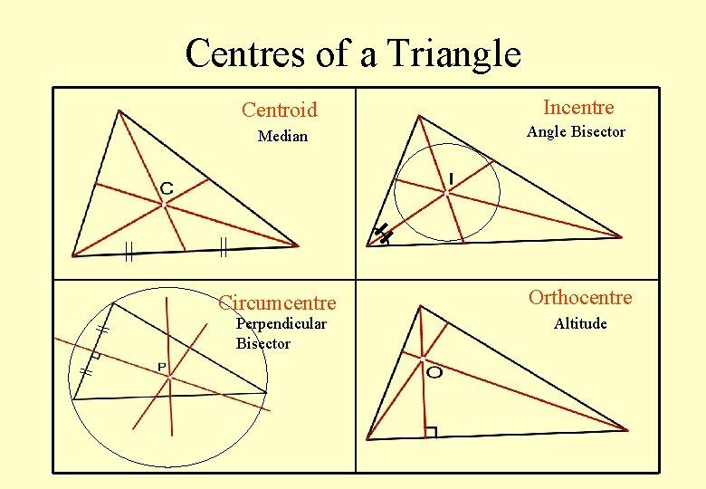
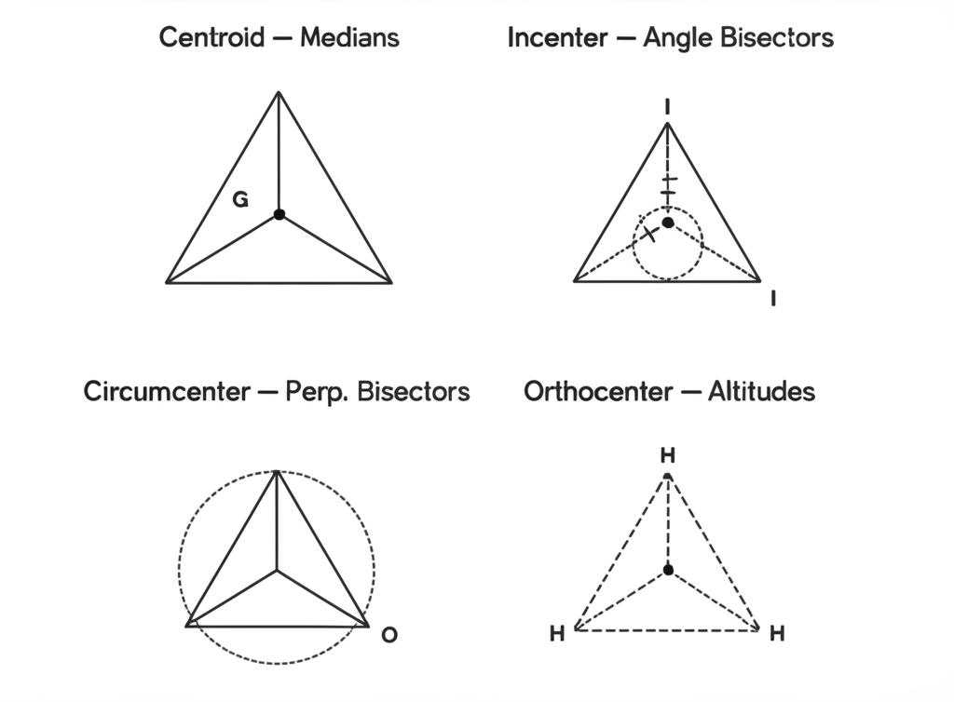
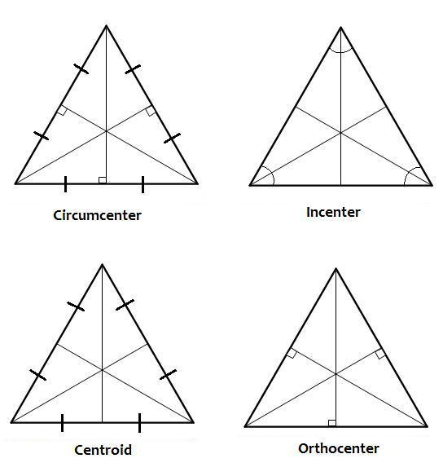

Special Case: Equilateral Triangle
# Source: AI Source: Provided by: [Data Path: Persons Table -> ID Column: 1, Name_En Column: Motasem Essam] -> From: [ChatGPT] on [7/25/2026]
In an equilateral triangle, the major triangle centers coincide.
Therefore:
$$\boxed{G=I=O=H}$$
where:
- $G$= centroid
- $I$= incenter
- $O$= circumcenter
- $H$= orthocenter
The common point is the center of the equilateral triangle.

Location of the Incenter
# Source: AI Source: Provided by: [Data Path: Persons Table -> ID Column: 1, Name_En Column: Motasem Essam] -> From: [ChatGPT] on [7/25/2026]
For every nondegenerate triangle:
$$\boxed{I∈interior⁡\left(△ABC\right)}$$
The incenter can never lie outside the triangle.
This is because the three internal angle bisectors intersect inside the triangle.

Important Properties
# Source: AI Source: Provided by: [Data Path: Persons Table -> ID Column: 1, Name_En Column: Motasem Essam] -> From: [ChatGPT] on [7/25/2026]
- Every nondegenerate triangle has exactly one incenter.
- The incenter is the intersection of the three internal angle bisectors.
- The three angle bisectors are concurrent.
- The incenter is always inside the triangle.
- The incenter is equidistant from all three sides.
- These equal distances are the inradius.
- The incenter is the center of the incircle.
- The incircle is tangent to all three sides.
- The triangle's area satisfies:
$$\boxed{A=rs}$$
- The incenter is different from the centroid, circumcenter, and orthocenter.

Classification
# Source: AI Source: Provided by: [Data Path: Persons Table -> ID Column: 1, Name_En Column: Motasem Essam] -> From: [ChatGPT] on [7/25/2026]
For your geometry knowledge-base hierarchy, I recommend:
Plane Geometry
└── Triangles
└── Triangle Centers
├── Triangle Centroid
├── Triangle Incenter
├── Triangle Circumcenter
└── Triangle Orthocenter
The Triangle Incenter is specifically a triangle center defined by the intersection of the three internal angle bisectors.

Related Concepts
# Source: AI Source: Provided by: [Data Path: Persons Table -> ID Column: 1, Name_En Column: Motasem Essam] -> From: [ChatGPT] on [7/25/2026]
The incenter is directly related to:
- Angle Bisector
- Angle Bisector Theorem
- Incircle
- Inradius
- Semiperimeter
- Triangle Area
- Tangency
- Triangle Centers
- Centroid
- Circumcenter
- Orthocenter

Key Formula Summary
# Source: AI Source: Provided by: [Data Path: Persons Table -> ID Column: 1, Name_En Column: Motasem Essam] -> From: [ChatGPT] on [7/25/2026]
Incenter definition
$$\boxed{I=\text{intersection of the three internal angle bisectors}}$$
Equal distances from sides
$$\boxed{ID=IE=IF=r}$$
Triangle area
$$\boxed{A=rs}$$
Semiperimeter
$$\boxed{s=\frac{a+b+c}{2}}$$
Inradius
$$\boxed{r=\frac{A}{s}}$$
Coordinate incenter
$$\boxed{I=\left(\frac{ax_{1}+bx_{2}+cx_{3}}{a+b+c} , \frac{ay_{1}+by_{2}+cy_{3}}{a+b+c}\right)}$$

Conclusion
# Source: AI Source: Provided by: [Data Path: Persons Table -> ID Column: 1, Name_En Column: Motasem Essam] -> From: [ChatGPT] on [7/25/2026]
The Triangle Incenter is the unique point where the three internal angle bisectors of a triangle intersect. It is the center of the triangle's incircle and is equally distant from all three sides.
Its most important relationships are:
$$\boxed{I=\text{intersection of the three angle bisectors}} \\ \boxed{ID=IE=IF=r}$$
and:
$$\boxed{A=rs}$$
Thus, the incenter connects angle bisectors, tangency, incircles, inradius, area, and triangle centers.

